STUDENT Joseph Roper

Salford College of further education | Future skills at MediaCity uk

BTEC National 90 Credit Diploma in Creative Media Production

Unit 74: Computer Game Story Development

Contents

Evidence of Idea Generation 2

Story Board 3

Overall Concept 5

Creating a story 5

Key Story Points 6

Characters – Types and Backstory 6

Narrative Flow 7

Reflection on finished story 7

A2: Be able to create story for a game following industry practice

# Evidence of Idea Generation

Just put all the pictures of the concept art, then check the notebook for the original story

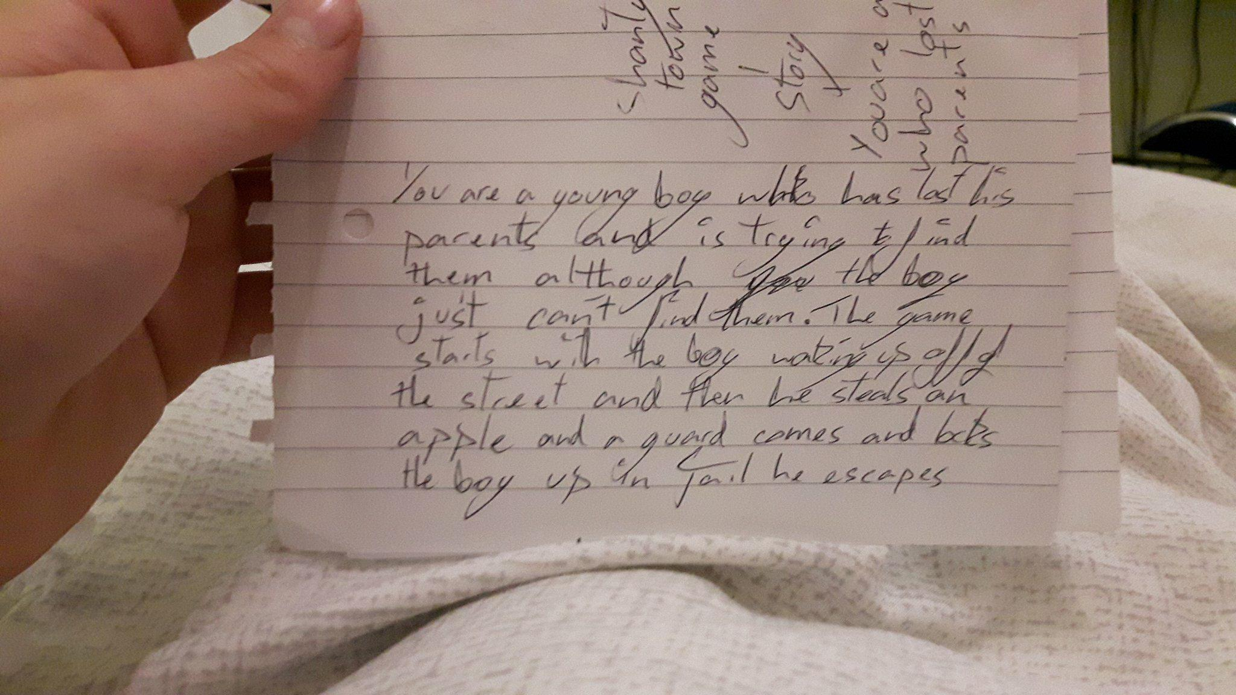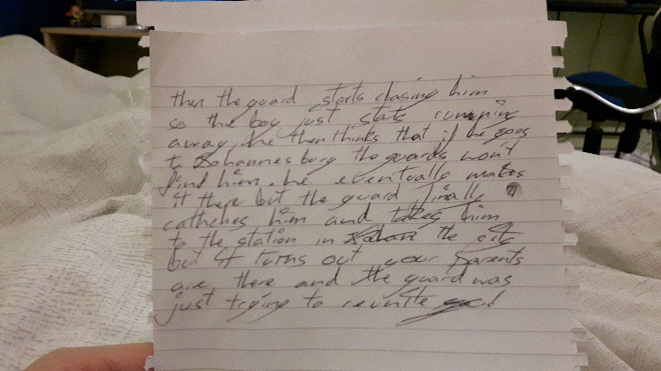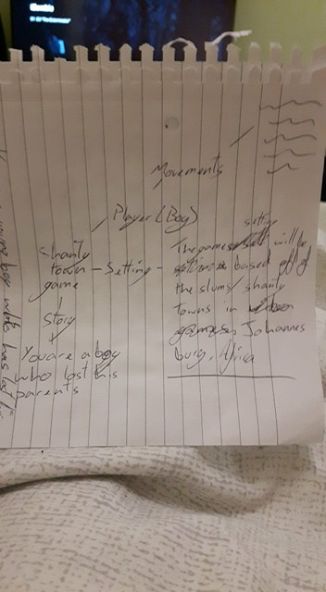

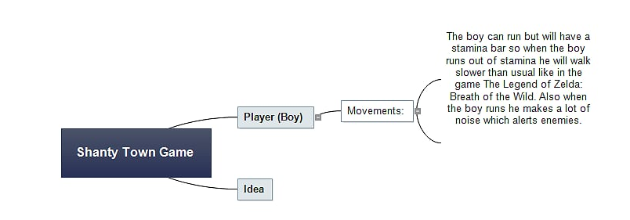

# Story Board

|  |  |
| --- | --- |
| Scene 1 | Scene 2 |
|  |  |
| Description: A young boy (the player) wakes up from sleeping on the dirty street floor. | Description: He walks around (while he player enjoys the scenery/view) and his stomach starts to rumble. |
| Scene 3 | Scene 4 |
|  |  |
| Description: The boy finds a stall selling bread but realises he has no money to pay, but his stomach continues to growl and roar. | Description: He decides to grab the bread and run but as he lays his finger on the bread the shopkeeper grabs his arm and says “Boy! Do you know what we do to thieves!” as he proceeds to pull out a big butchers knife. |
| Scene 5 | Scene 6 |
|  |  |
| Description: Suddenly a guard shouts stop and walks to the shopkeeper saying “can’t we be civilised? And lock him up?”. | Description: The guard grabs you a throws you in a cell. Then the game starts as you have to escape the cell and run away from home to the big city. |

# Overall Concept

Game Title: Boy

Genre: Adventure, Platformer you will be going through the slums climbing scaffolding.

Target Audience: 12+

General audience: Teenagers to young adults.

Gameplay: Parkour, Obstacles/Puzzles like the game Little Nightmares where the character is so small compared to the rest of the world and you never feel safe but also like the game Inside where you have to hide from the enemies and make your way past them. In the game when necessary the child will be able to throw rocks to stun enemies or hit objects to solve puzzles.

[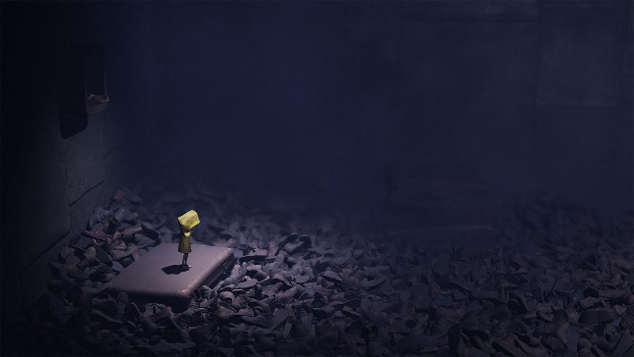](https://uk.gamesplanet.com/game/little-nightmares-steam-key--3162-1)[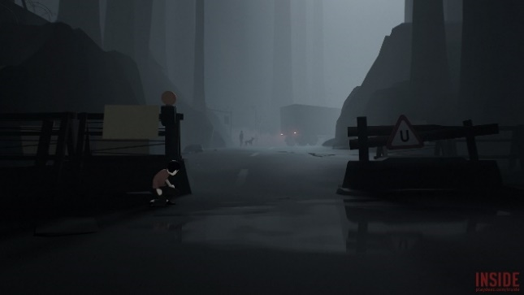](https://waypoint.vice.com/en_us/article/vvkzz8/the-unifying-monstrous-hopefulness-of-inside)

Colours: Dreary colours, brown, dark brown etcetera



Player: Young child – Silent protagonist, will wear a bright coloured t-shirt so the player can see them on the screen.

Setting: A shanty town

# Creating a story

Story: The player a young child tries to steal bread from a shop keep in a shanty town and ends up getting caught, the punishment is death he has to escape and run away everyone is trying to chase him so he has to jump onto unsafe roofs and run for his life until he gets to the big city. Safety. He has to do all of this while still maintaining his health by getting food and drink, washing and well not dying from sharp objects. The boy’s objective is to make it to the big city where he has heard dreams come true and people don’t starve there. At the end of the game when the boy makes it to the big city he ends up getting finally caught by the guard who first threw him in jail he takes him to the local police station to meet his parents which the guard was trying to do in the first place. The guards and everyone calls the child boy but when he meets his parents at the end of the game he finds out his name is Mvulana which is Swahili for boy so the whole game everyone was just calling out his name to get him home safe to his parents.

[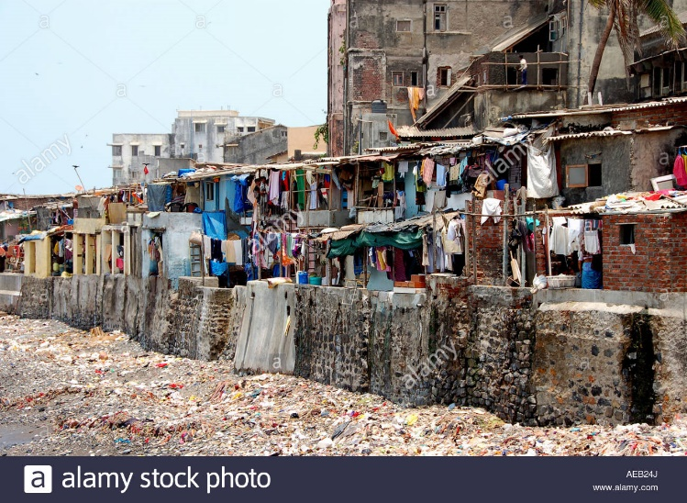](http://www.alamy.com/stock-photo-shanty-town-in-mumbai-or-bombay-viewed-from-a-taxiing-aircraft-at-78006577.html)[](https://propertydrum.briefyourmarket.com/Article.aspx?id=558)

He would have to climb up places like this while avoiding guards and thieves or just criminals.

# Key Story Points

1. Boy loses his parents gets lost in a shanty town.
2. Wakes up hungry, steals from a shop.
3. Police caches him and locks him up.
4. Boy escapes the holding cell, and starts getting chased by the police chief.
5. Boy figures out he has to get to the big city.
6. Boy griefs over the death of his little sister.
7. Boy makes it to the big city then gets caught by the police chief.
8. Boys gets brought to the big city police station and gets reunited with his parents.
9. The end.

# Characters – Types and Backstory

Character’s Name: Mvulana

Character Type: Protagonist

Character Backstory: He is 12 years old and has parents, he used to have a little sister who was stoned to death for committing a crime no one knows. Mvulana has been haunted by his sister’s death and because of this he trusts no one apart from his parents.

Capabilities: Mvulana is quick, nimble and also small meaning he can fit through small holes and cracks.

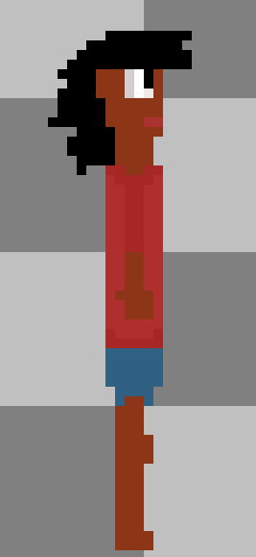

Character’s Name: Head Guard

Character Type: Antagonist

Character Backstory: He is the head guard of the police force from the big city and is currently working in the slums to stop violence that is why he stopped the shop keeper from attacking Mvulana. He also is old friends with Mvulana’s parents and that is why he took Mvulana to the station to reunite him with his parents.

Capabilities: Is big and strong and has a sword on him.

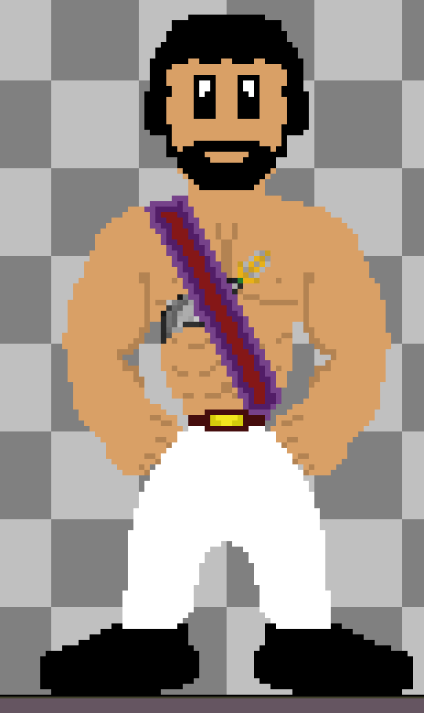

# Narrative Flow

My game will be extremely linear as the main focus of the game is the story so I want the players to experience it the way I want.

To make the story linear it will start off with a cut-scene of the boy walking with his parents in the big city when they suddenly split apart and the boy gets lost. You then see the boy sleeping on the ground and you wake him up by inputting a control, then you will be able to freely walk around the map although your stomach will keep rumbling hinting that you have to go to the food stall, and when you do another cut scene starts where you steal the apple then get thrown in jail. You then start to control the character again and try to escape your cell by puzzle solving.

# Reflection on finished story

I believe my story has developed well compared to its initial design. As it just started off with a lost child then I added his backstory with his parents and how he got lost so that the player can create an emotional attachment to the character making them sympathise with the boy. Then in the middle of the game, the player will find out about the boy’s little sister and her death adding more weight to the story. The boy’s sister will act as a plot device and sub plot in the middle of the story as a crutch to the player as they will have to try and get over the death of his sister so you can carry on and an venture to the big city. There will also be side stories added to the game for example to make it up to the shop keep you stole from by doing various errands for him although this is unnecessary however you will get better clothes as a gift once the errands are complete.

My story stills applies to the brief and fits into the target audience which is 12+, it is still a single player adventure platformer with puzzles.

# Twine Story

This is the overview of my Twine story to access it fully you can go on <http://twinery.org/2/#!/stories/e41a73b2-c056-47e1-a776-326ae919ece2> then download the file named Unknown then click and drag it onto the Twine home page. You will then be able to view each tile to see the story dialogue and paths as well as the code for the story. The story right now isn’t complete as when you go to the town the story doesn’t continue after that. Although the story currently is more or less linear as if you don’t die and take all the paths you will most likely end up at the dragons cave, however that is how I want the story to be as if the player could go down completely different story paths they won’t experience the games true story. For the games code I used Sugarcube as it comes with Twine, for the code I have made the sleeping system, slot machine and shop that all work and will be used to further advance the story as you will need to by certain armour to complete specific quests to carry on the story.

